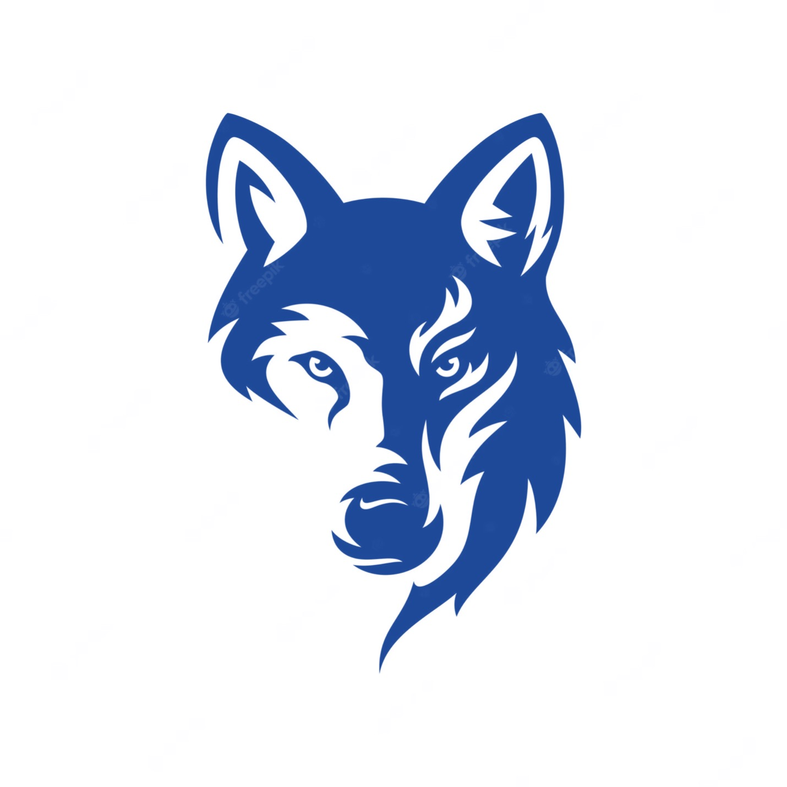
CITRUS COUNTY WOLVES SPONSHORSHIP FORM

SPONSORSHIP PACKAGES

PLATINUM LEVEL - 3,000 Includes: Team T-Shirt, shout out at all home games, Company Logo on Team Page, 4 Game tickets, Team wall Plaque, Booth Setup at Home games, and Team cup.

GOLD LEVEL - $1,500 Includes: Team T-Shirt, shout out at all home games, Booth Setup at Home games, Company Logo on Team Page, 4 Game tickets, and Team wall Plaque.

SILVER LEVEL - $1,000 Includes: Team T-Shirt, shout out at all home games, Company Logo on Team Page, and 2 Game tickets.

BRONZE LEVEL - $500 Includes: Team T-Shirt, shout out at all home games, Company Logo on Team Page, and 1 Game ticket.

Under $500 - Includes: Team T-Shirt, and Koozie.

CONTACT INFORMATION

NAME: ____________________________
BUSINESS NAME: _______________________________
EMAIL: _______________________________________
PHONE: ___________________________
ADDRESS: _____________________________________________________________
SPONSHORSHIP LEVEL: _________________________
SHIRT SIZE: ___________________________

PAYMENT METHODS
- MAIL THIS FORM AND YOUR CHECK (MADE OUT TO “KENT GARNETT”) TO: 9222 S ZANMAR DRIVE FLORAL CITY FL 34436
- PAY ONLINE ON OUR TEAM PAGE AND CLICK THE PAYPAL BUTTON.
PLEASE INDICATE IN THE COMMENTS WHAT YOU ARE PAYING FOR.
PLEASE EMAIL YOUR PAYPAL RECIEPT TO: KENTGARNETT83@OUTLOOK.COM
https://www.facebook.com/CitrusCountyWolves/

THANK YOU OR YOUR SPONSORSHIP. IF ANY QUESTIONS PLEASE CONTACT KENT AT 352-631-2707

